JPR Assignment 5
1. List constructors of ServerSocket class.
Ans.
1. ServerSocket() throws IOException
2. ServerSocket(int port) throws IOException
3. ServerSocket(int port, int backlog) throws IOException
4. ServerSocket(int port, int backlog, InetAddress bindAddr) throws IOException

2. Define ProxyServer and Reverse socket.
Ans.
1) Proxy Server: A proxy server acts as an intermediary between a client and
the internet or another server. It forwards client requests to the target server
and then returns the server’s response to the client. Proxy servers help
improve security, control access, and cache data to speed up requests.

2) Reverse Socket: A reverse socket (often called a reverse shell) is a
connection where a remote device connects back to a local machine to
provide access or control. It is commonly used for remote administration
or troubleshooting when the local machine is behind a firewall or NAT,
allowing the remote system to initiate the connection.

3. Differentiate between TCP and UDP.
Ans.
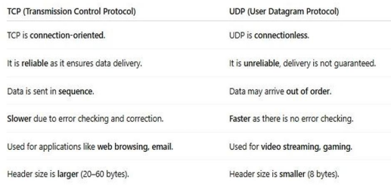

4. WAP using URL class to retrieve the host. protocol, port and file of URL
http://www.msbte.org.in
Ans.
import java.net.URL;
public class URLInfo
{
public static void main(String[] args)
{
try
{
URL url = new URL("http://www.msbte.org.in");
System.out.println("Host: " + url.getHost());
System.out.println("Protocol: " + url.getProtocol());
System.out.println("Port: " + url.getPort());
System.out.println("File: " + url.getFile());
}
catch (Exception e)
{
e.printStackTrace();
}
}
}

